- Webserver and App server
Install ngnix and run on port number 81 r
sudo apt install nginx –y

Change port to 80 to 81
sudo nano /etc/nginx/sites-available/default
find this line → listen 81;
Change to → listen 81;

just change defult settings to change port 80 to 81

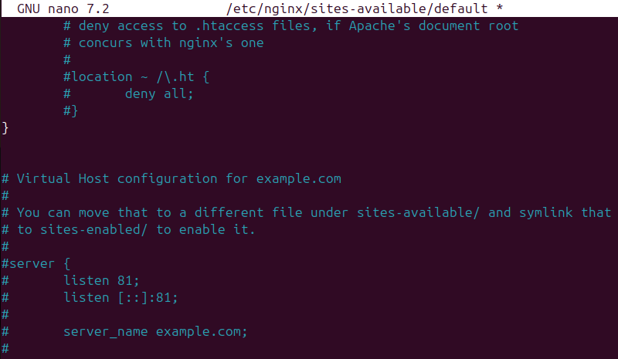

After that press ctrl+x ctrl+s then press enter
Now port has been change

With help of this command we can find that our server is running on 81
sudo netstat -tuln | grep 81

Nginx is successfully running on port 81

- Deploy a sample index.html file on nginx r
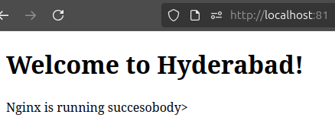
This is where Nginx serves your website files from
cd /var/www/html
now make ur own file using
( nano command )
ls check
And type this use vi index.html
Inside in it nano edit ur html file and save it

- Install Apache and run Apache on port 82 r

Step 1: Install Apache
1. sudo apt update
2. sudo apt install apache2 –y

Step 2: Change Apache port to 80 to 82
first goes this path (sudo nano /etc/apache2/ports.conf)
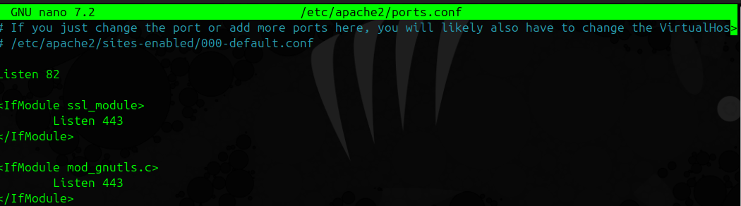
Find the line
Listen 80 change it to Listen 82
Now goes this path to configure the site
sudo nano /etc/apache2/sites-available/000-default.conf
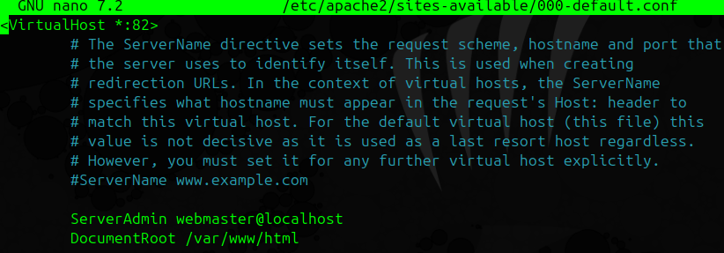
Find: <VirtualHost *:80> just change this 80 into ur port in my case I went it 82
Save both files (Ctrl + O, Enter, Ctrl + X)

Step 3. Restart Apache
sudo systemctl restart apache2 (you can check it working or not by simple going on localhost (http://localhost:82)

Now our apache is successfully running on 82

4.Install Apache tomcat on port number 8082 5

To install apache tomcat
Type kernel ( sudo apt install apache2 –y) my case its already install
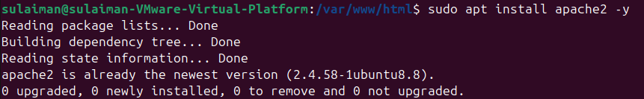
Now go to this path change your port:
sudo nano /etc/apache2/ports.conf

Edit the default site config
sudo nano /etc/apache2/sites-enabled/000-default.conf
Find this line:
<VirtualHost *:80>
Change it to:
<VirtualHost *:82>

- Deploy a sample index.html file on Apache. 4

Now set this path Go to the web root folder
cd /var/www/html

Create or edit the index.html file
(You can use nano editor)
sudo nano index.html ( nano is a text editior )

Add this sample HTML:
<!DOCTYPE html>
<html>
<head>
<title>Welcome to Apache</title>
</head>
<body>
<h1>Apache Server Deployed Successfully!</h1>
<p>Hello from your Apache Web Server!</p>
</body>
</html>
In place of hello from your apache web server you place any message u went display on ur apache server

Now restart your apache2 server with command
sudo systemctl restart apache2



Now notice we have successfully edit our html file

- Deploy a Sample App on Apache Tomcat

Go to your Tomcat webapps directory

cd /opt/tomcat/tomcat9/webapps

Step 2: Create a new folder, directory for your app
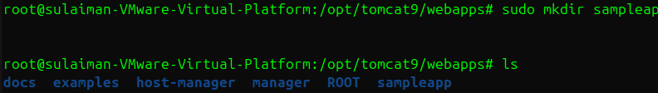

sudo mkdir sampleapp ( mkdir is used create directory )

Step 3: Create a simple index.html file

Inside the folder:

cd sampleapp
sudo nano index.html ( inside nano we gonna paste this script ) html script
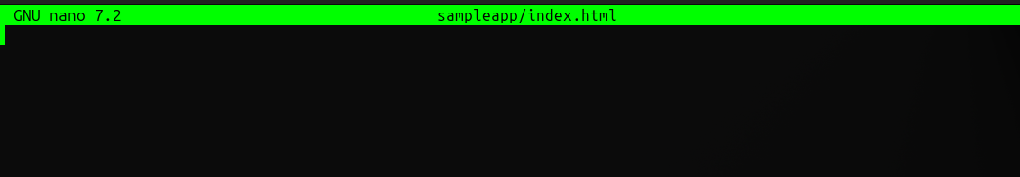

<html>
<head>
<title>Welcome to My Sample App</title>
</head>
<body style="background-color:#f0f0f0; text-align:center;">
<h1>Hello from Tomcat Sample App!</h1>
<p>This app is running on port 8082</p>
</body>
</html>
(In place of hello from tomcat sample app you can edit to our own message)
Save the file → Ctrl + O, Enter, then Ctrl + X
now simple restart your apache tomcat server
./shutdown.sh
./startup.sh
Finally step check it out
Now go to your browser and visit:
http://localhost:8082/sampleapp

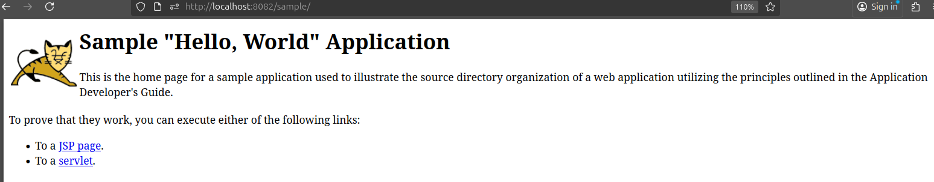
Finnaly our apache tomcat sampleapp display on port: 8082

- Create a tomcat.service file for tomcat

This will create a new file called tomcat.service inside /etc/systemd/system/

Paste this exact content into the editor
[Unit]
Description=Apache Tomcat Web Application Container
After=network.target

[Service]
Type=forking

# Recommended: run as unprivileged user 'tomcat' (change to root if needed)
User=tomcat
Group=tomcat

# Adjust JAVA_HOME to the path from step 2 if different
Environment="JAVA_HOME=/usr/lib/jvm/java-11-openjdk-amd64"
Environment="CATALINA_HOME=/opt/tomcat"
Environment="CATALINA_BASE=/opt/tomcat"
Environment="CATALINA_PID=/opt/tomcat/temp/tomcat.pid"
Environment="CATALINA_OPTS=-Xms512M -Xmx1024M -server -XX:+UseParallelGC"

ExecStart=/opt/tomcat/bin/startup.sh
ExecStop=/opt/tomcat/bin/shutdown.sh

Restart=on-failure
RestartSec=10

[Install]
WantedBy=multi-user.target

Reload systemd so it reads the new unit

Command: sudo systemctl daemon-reload

Enable the service (start at boot)

Command to enable : sudo systemctl enable tomcat

Command to start : sudo systemctl start tomcat

Check the service status
Command : sudo systemctl status tomcat

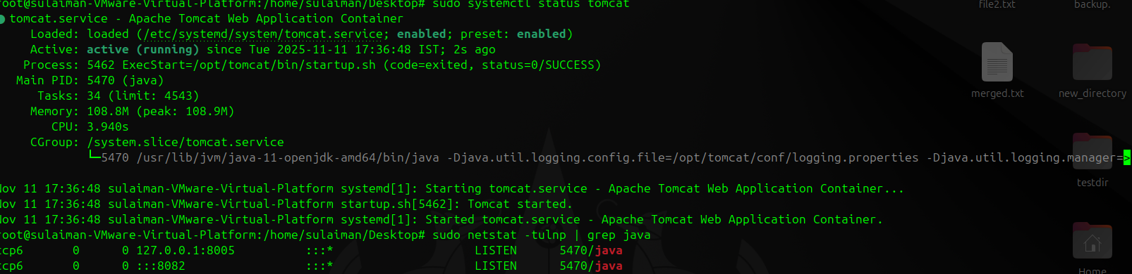

We have successfully Create a tomcat.service file for tomcat

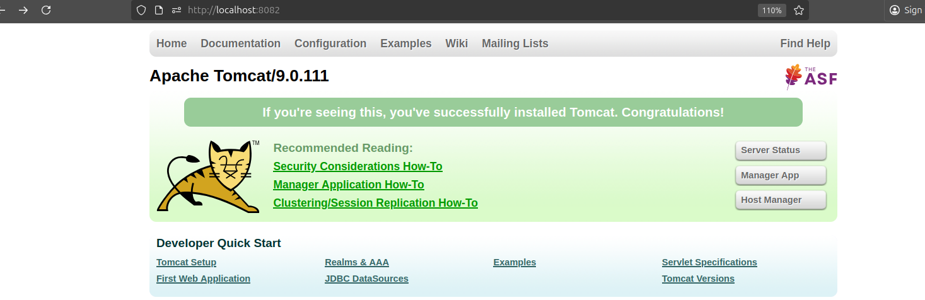

8 Configure HA proxy server
Step 1 — Make sure all 3 web servers are running

First start my ngnix which port is 81
Second start my Apache on Port 82
Third start my Tomcat on port 8082
Install HAProxy
Command: sudo apt install haproxy –y
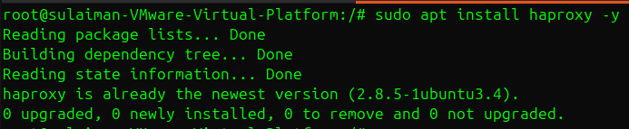

Enable and start it:
sudo systemctl enable haproxy
sudo systemctl start haproxy
sudo systemctl status haproxy

Open the main configuration file:
Command: sudo nano /etc/haproxy/haproxy.cfg

Scroll to the bottom of the file (below defaults) and add this configuration block:
frontend http_front
bind *:80
mode http
default_backend web_back

backend web_back
mode http
balance roundrobin
option httpchk HEAD / HTTP/1.1\r\nHost:\ localhost
server nginx_server 127.0.0.1:81 check
server apache_server 127.0.0.1:82 check
server tomcat_server 127.0.0.1:8082 check
Then save and exit:
- Press CTRL + O, ENTER, then CTRL + X
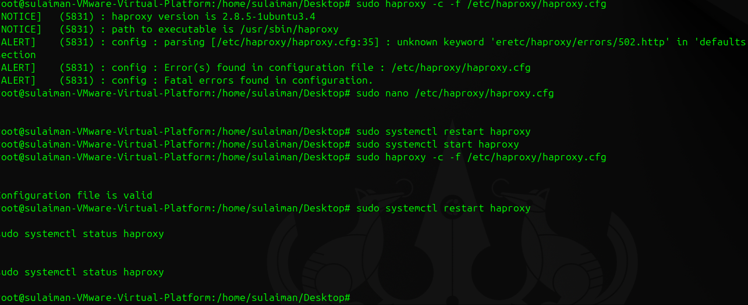

So finnaly out haproxy working


